Comp 330 Assignment 1

# Question 1

## Question 1.1

Equivalence class R:

* Reflexive: $xRx$
* Symmetry: $xRy <=> yRx$
* Transitive: $xRy \& yRz=>xRz$

Preorder:

* Reflexive
* Transitive

**Proof:**

* Reflexive

$$a\sim a⇔a R a \& a R a$$

As R is a preorder its reflexive then ~ is also reflexive

* Symmetric

$$a R b \& b R a ⇔a \sim b$$

$$b R a \& a R b ⇔b \sim a$$

$$a R b \& b R a ⇔a \sim b$$

Then ~ is symmetric

* Transitive

$$a R b \& b R c→a R c$$

$$c R b \& b R a→c R a$$

$$a R b \& b R a \& b R c \& c R b→a R c \& c R a$$

$$a\sim b \& b \sim c→a \sim c$$

Then ~ is transitive and thus an equivalence class



## Question 1.2

We have

* $[a]$ the set of element equivalent to a with ~ equivalence
* $[b]$ the set of element equivalent to b with ~ equivalence

**Case 1: a is equivalent to b**

Then by definition of equivalent classes $\left[a\right]=[b]$

Then for any $x∈\left[a\right]and y∈\left[b\right], x\sim y→xRy$

Thus it’s well defined in this case

**Case 2: a is not equivalent to b**

Then $\left[a\right]≠ [b]$

Then for any $x∈\left[a\right]and y∈\left[b\right], not x\sim y→not xRy$

Thus its well defined

## Question 1.3

$$\left[a\right]≤\left[b\right] \& \left[b\right]≤[a]$$

$$aRb \& bRa$$

$$a\sim b$$

But as $a\sim b$ then $[a] and [b]$ are the same set ($\left[a\right]=[b]$) and then $≤$ is anti-symmetric

# Question 2

## Question 2.a

* Reflexive

Let $x=x_{1}x_{2}…x_{n}$

For all $i, x_{i}=x_{i}$ then the first condition cannot be competed

However x is a prefix of x then $x≤x$

* Transitive

Let $x=x_{1}x_{2}…x_{n}$ and $y=y_{1}y_{2}…y_{m}$ and $z=z_{1}z_{2}…z_{s}$

We also have $x≤y and y≤z$

Let $i$ such that either $x_{i}=a and y_{i}=b$

Let $j$ such that either $y_{j}=a and z_{j}=b$

We know that for all $k<i , x_{k}=y_{k}$

We know that for all $k<j , y_{k}=z_{k}$

If $i< j$ then for all $k<i, x_{k}=z_{k}$ but as $x_{i}=a and y_{i}=b and y_{i}=z_{i} then z_{ i}=b$ and then $x≤z$

If $i > j$ then for all $k<j, x_{k}=z_{k}$ but as $y_{j}=a and z_{j}=b and x_{j}=y_{j} then x_{j}=a$ and then $x≤z$

If $i=j$ then either x = y or y = z and thus $x≤z$

Similarly if $x$ is a prefix of $y$ or $y$ is a prefix of $z$ we get $x≤z$

* Anti-symmetric

Let $x=x_{1}x_{2}…x_{n}$ and $y=y_{1}y_{2}…y_{m}$

Let $x≤y and y≤x$ then

* $∃i s.t x_{i}=a and y_{i}=b$ and $∀ k<i, x_{k}=y_{k}$
* $∃j s.t x_{j}=b and y_{j}=a$ and $∀ k<j, x_{k}=y_{k}$

However those two conditions are not possible to satisfy at the same time.

Similarly if x is shorter than y then the $y≤ x$ conditions won’t be satisfied. Same for y shorter than x

Then $m=n$ and as the first conditions showed for all $k, x_{k}=y_{k}$ then $x=y$

So it’s anti-symmetric

## Question 2.b

It’s not well founded.

Indeed we can have a sequence of a and b named $w=aa…ab$

Let $w'$ be the word compose of $a and w:w^{'}=aaa…ab$

But $w'$ is smaller than $w$.

We can repeat this step indefinitely so there is no minimal element

# Question 3

## Question 3.1

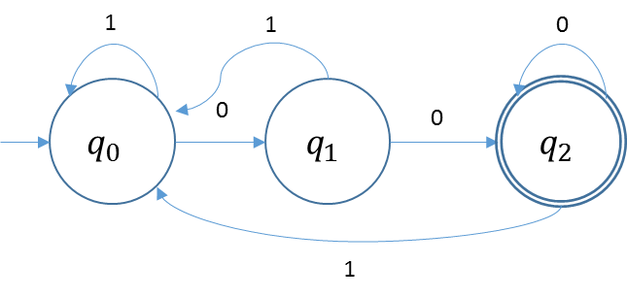

## Question 3.2

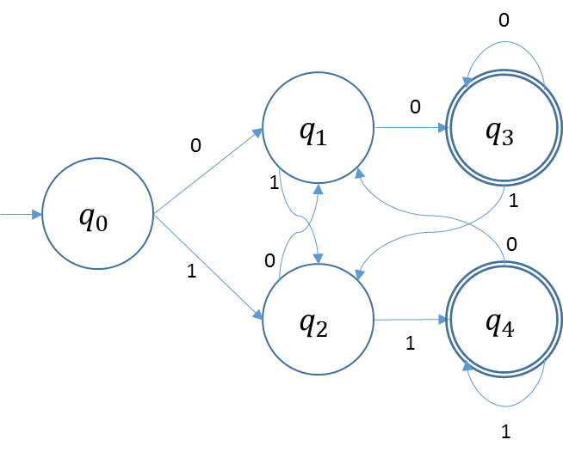

## Question 3.3

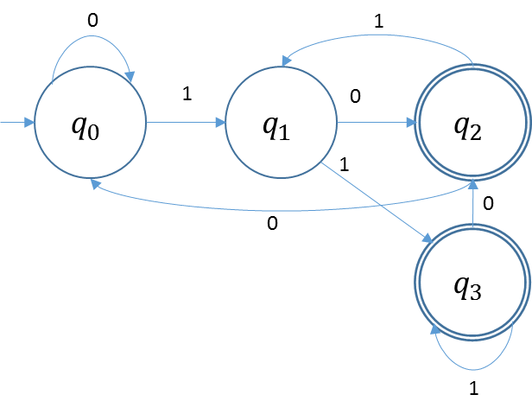

# Question 4

$Rev(L)$

Let $M(S, s_{0}, δ_{1}, F)$ be a machine that recognize $L$

Let $N(T, t_{0}, δ_{2}, F_{0})$ with

$T=S∪\{t_{0}\}$

* $t_{0}$ is a new state that has $ϵ$ transistions to all final states in $F$
$F_{0}=s_{0}$

* $δ_{1}\left(x,a\right)$ all transitions in M are reversed

$Init(L)$

Let $M(S, s_{0}, δ_{1}, F)$ be a machine that recognize $L$

Let $N(T, t_{0}, δ_{2}, F_{0})$ with

$T=S$

$t_{0}=s_{0}$

$F_{0}=F$

$δ_{1}\left(x,a\right)= δ_{2}(x, a)$

New transitions have been added that loop on the final state

# Question 5

Let $M(S, s_{0}, δ_{1}, F)$ be a machine that recognize $L$

Let $N(T, t_{0}, δ_{2}, F_{0})$ be a machine that recognize $lefthalf(L)$

* $T=S*S∪\left\{t_{1}\right\}$. So $S*S$ keep track of the current state of $M$ as well as the state that can reach an accept state of $M$ in i move steps where i is the current length of the word we are reading
* $t_{0}$ we have an $ϵ$ move $s_{0}$ and note that we are 0 steps from an accepted state
* $F_{0}=\left\{\left(x,x\right)\right| x ∈S\}$ So we accept only if the current state is at x, and x is at i steps from an accept state of $M$
* ${(δ}_{1}\left(x, a\right), z) ={(δ}_{2}\left(x, y\right), a)$ where $∀z$ that satisfies the previous equation, $∃ c∈Σ with δ_{2}\left(z, c\right)=y$